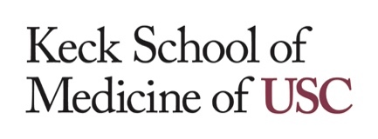

Have you been a victim of financial fraud or scams?
If so, you may be eligible to participate in a research study!

The Department of Family Medicine at the Keck School of Medicine at USC is seeking individuals for a non-medication research study. The study will take place at our offices in Alhambra, CA. We hope to learn if financial wellbeing is associated with certain thinking, emotional, and health factors. We are also interested in individuals who have never experienced financial fraud or scams.

Participants must be:

- 50 years or older and fluent in English
- No history of current or past substance abuse
- No major medical problems with brain or emotional functioning
Study includes:
- Behavioral Data Collection: Pencil-paper and computerized measures examining thinking abilities, emotions, and health

- Neuroimaging Session: Brain MRI scan

Money will be given for participation. Transportation to and from study site can be provided. If you are interested in learning more about this study or have any questions, please contact Dr. Duke Han’s research group at HanResearchLab@gmail.com or call (626) 457-4213. A member of our team will follow up with you.

Thank you for your interest in our research!
FCNDA STUDY
626-457-4213
HanResearchLab@gmail.com
FCDNA STUDY
626-457-4213
HanResearchLab@gmail.com
FCDNA STUDY
626-457-4213
HanResearchLab@gmail.com
FCDNA STUDY
626-457-4213
HanResearchLab@gmail.com
FCDNA STUDY
626-457-4213
HanResearchLab@gmail.com
FCDNA STUDY
626-457-4213
HanResearchLab@gmail.com
FCDNA STUDY
626-457-4213
HanResearchLab@gmail.com
FCDNA STUDY
626-457-4213
HanResearchLab@gmail.com
FCDNA STUDY
626-457-4213
HanResearchLab@gmail.com
FCDNA STUDY
626-457-4213
HanResearchLab@gmail.com
FCDNA STUDY
626-457-4213
HanResearchLab@gmail.com
FCDNA STUDY
626-457-4213
HanResearchLab@gmail.com
FCDNA STUDY
626-457-4213
HanResearchLab@gmail.com

